Chapter 3, Problem 10.

Find i₀ in the circuit in Fig. 3.59.

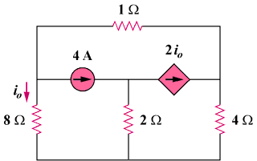

Figure 3.59
For Prob. 3.10.

